**THEME: BAKERY AND RESTAURANT PAGE**

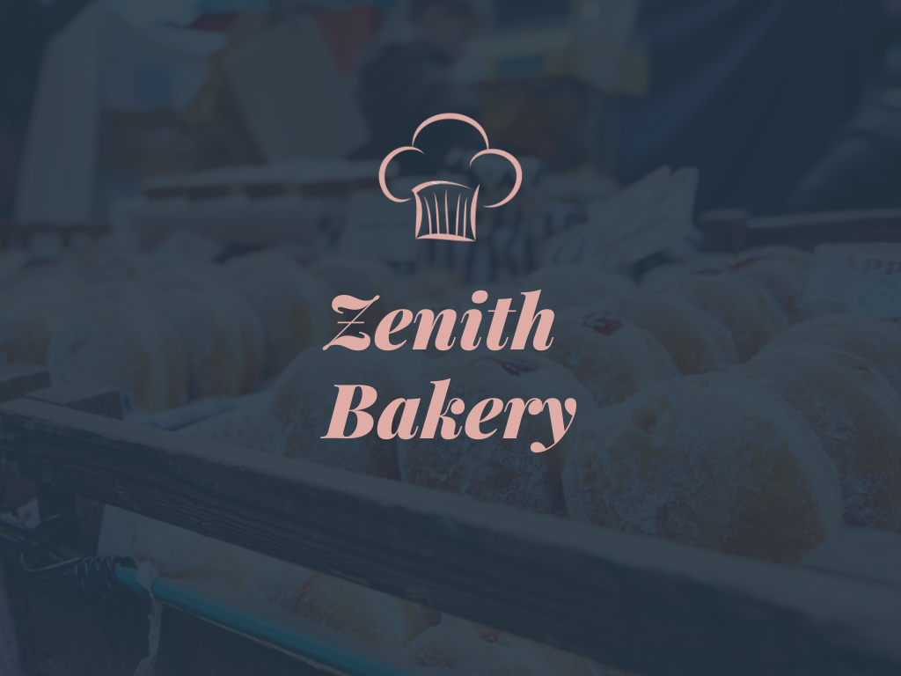

**Introduction**

The name “Zenith” means the time at which one is most successful and powerful. I want my bakery to earn huge profits and at the same time help millions of people eat something mind refreshing and savoring, giving them a break from their monotonic daily routine. Hence, helping people to increase their productivity and also helping them reach their greatest height.

**Progress Report – 1**

The progress for 12- hours is as follows -

1. Decided a name for my bakery – Zenith Bakery: A home for sweet bread and pastries.
2. Created a logo
3. Decided a 2-page menu for my bakery
4. Decided illustrations to be used in website
5. Created nav bar and finalized the look of the website
6. Added an animated text effect on landing page.

**TECH – STACK/ RESOURCES**

1. HTML
2. CSS
3. CANVA